Machine Learning II  Diploma in DS  Year 2 2025/2026 Oct | Week 13
Machine Learning II  Diploma in DS  Year 2 2025/2026 Oct | 2 hours
Week 13: CI/CD Pipeline

Objectives
By the end of this practical, you will be able to:
- Set up a CI/CD pipeline with Giithub Actions for Automated Deployment
- Be familiar with basic Git actions
- Execute Fork and Merge Branches
- Apply Git Actions to effect CI/CD processes

Introduction to Github Versioning [Optional]
- Sign in to Github
- Create a new repository
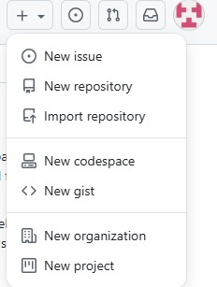

- Specify a suitable repository name and “Create repository”

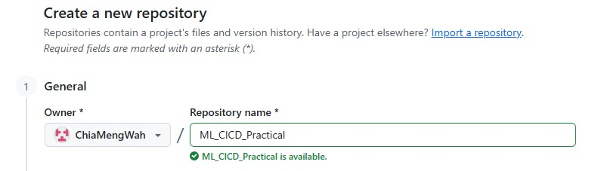

Once you have successfully set up your repository, you will see the following. Take note of the url of your repository

Github Desktop Installation
You may installing Github Desktop to your system. Once you have installed, ensure that you can open Git Bash.

Create your project folder
- Create a folder and named it ML2_Practical
- Go into the folder using your Git Bash • Create a readme file using echo "# ML_CICD_Practical" >> README.md

- git init
- git add ./
- git commit -m "first commit"
- git branch -M main o git branch feature-branch o git checkout feature-branch
- git remote add origin https://github.com/ChiaMengWah/ML_CICD_Practical.git • git push -u origin main

View your files on Github

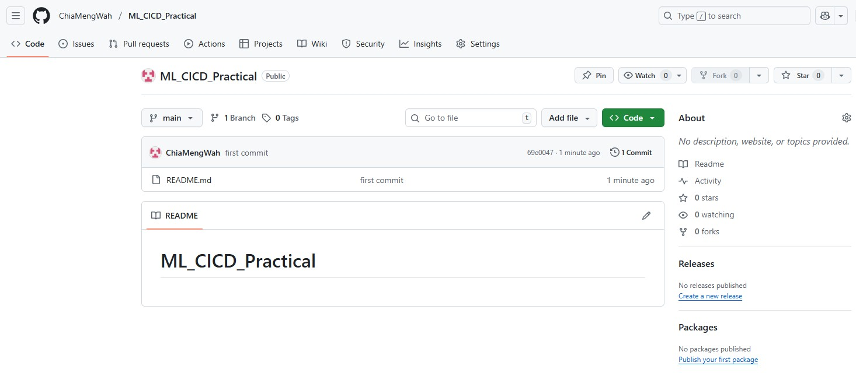

It is good practice to fork a branch from the main branch
- Go to the folder
- git init
- git checkout -b feature-branch

Now you may introduce new features or files to this feature-branch. To commit the changes • git ./addgit commit -m "first commit"

At this instant, your changes is only confined to your local computer. You can push the amendments online.
- git push -u origin feature-branch

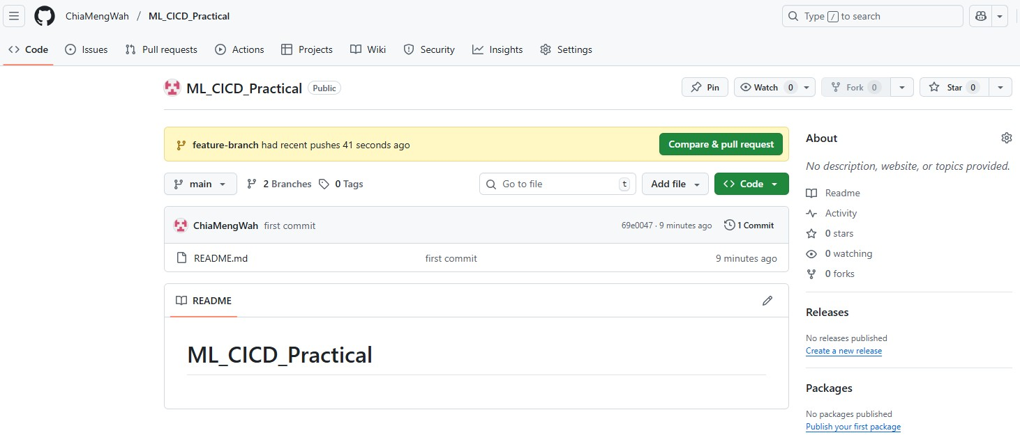
Go to your Github url and you will be able to see the committed branch. You may compare the differences between the forked branch and the main branch. Alternatively, you can view the differences on your Git Bash using git diff main..feature-branch Remember to use “q” to get out of the “reading” mode.

Merging Branches
Now, we are comfortable with the changes of the forked branch and we wish to update the main branch. We can use the following:
- git checkout main
- git pull origin main
- git merge feature-branch
- git push origin main

At this point, we have only merged the changes from the forked branch onto the main branch. The branches still remains on your Github repository.
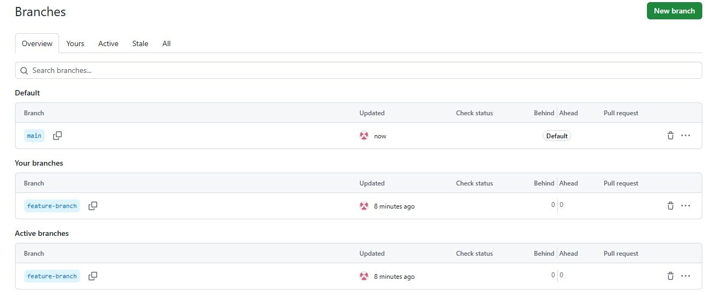

Deleting Branches
To delete the branches, you will need to delete the copy on your local computer and your remote repository.

git branch -d feature-branch
git push origin --delete feature-branch

Once deleted, you can verify it on your repository.
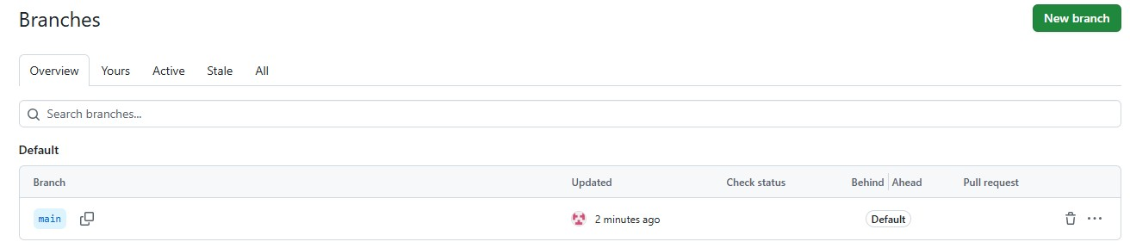

Customizing Repository Settings
On your repository online, go to the Settings option.

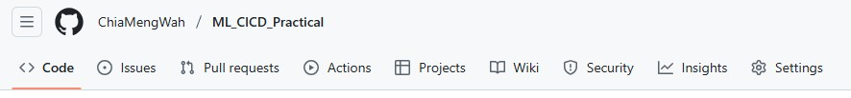

You may switch the repository to private and can even delete your repository in this setting.
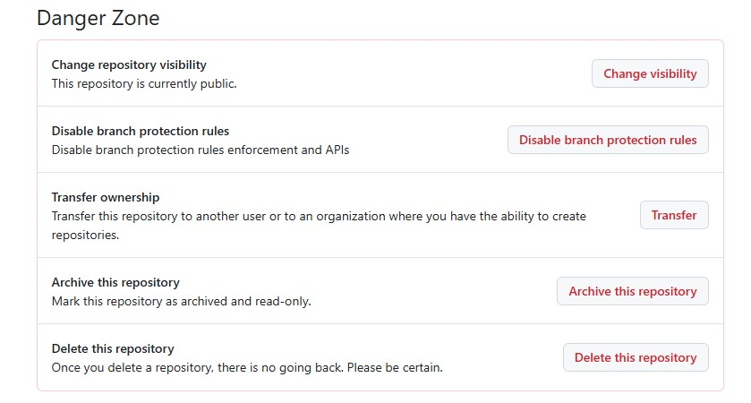

Setting Up CI/CD for DevOps
Review the view for your remote learning. Set up the environment provided in the LinkedIn learning for CI/CD and provide your URL in the submission page.

Setting up Project folder
- By now, you should be familiar with setting up your repository. On your Github repository, create a repository named PreprocessingCICD.
- Clone this repository onto your local drive and create the following folders.

PreprocessingCICD
├─ src/
├─ tests/
├─ configs/
├─ data/
│ ├─ raw/
│ └─ processed/

- Copy and paste your requirements.txt into your PreprocessingCICD folder.
- Copy and paste your sample.csv data file into folder /data/raw/. You will use this file to develop and test various data preprocessing algorithms.
- Go to /src folder:
  - Create a file __init__.py file. This will allow our directory to be treated as a package, i.e. to be able to import modules from that directory using standard Python import syntax.
  - Paste the files preprocess.py, preprocess_pipeline.py into the folder.
- Go to /configs folder and paste the file preprocess.yaml into the folder
- Run your terminal from PreprocessingCICD using
  - python src/preprocess.py --config "configs/preprocess.yaml"
- Once successful, you should be able to see
- Next, go to the tests folder and paste the file test_preprocess.py. These files will be used by pytest library during your CI/CD process.
- Return to the main folder and run from your terminal:
  - python tests/test_preprocess.py
  - If you do not have an error, then your setup process is correct.

- Return to the main folder and run from your terminal:
  - python tests/test_preprocess.py
- Once done, commit the changes onto your Git repository online. You should have the following hierarchy:

PreprocessingCICD
├─ src/
│ └─ preprocess.py
├─ tests/
│ └─ test_preprocess.py ├─ configs/
│ └─ preprocess.yaml
├─ data/
│ ├─ raw/
│ └─ processed/
├─ requirements.txt

Setting up Git Actions
- Go to your repository and select Actions
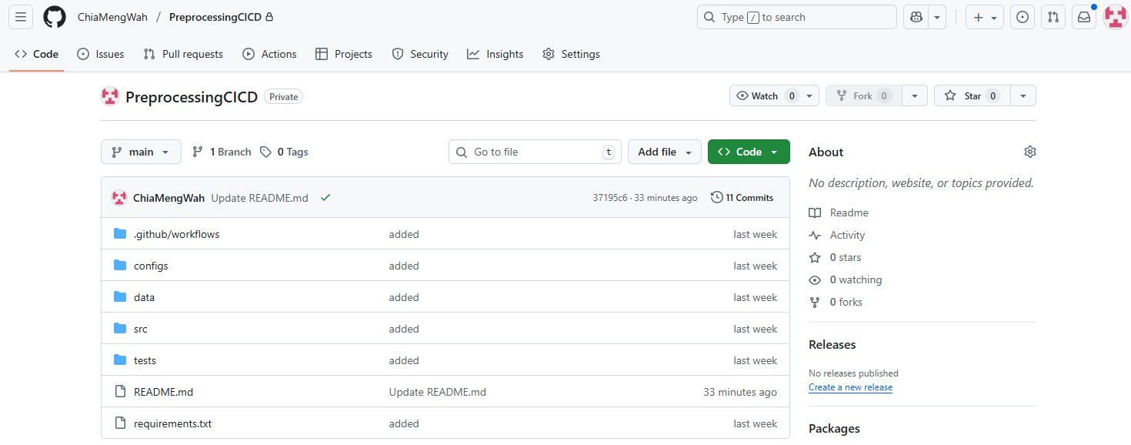

- Search for Python application and choose to Configure it
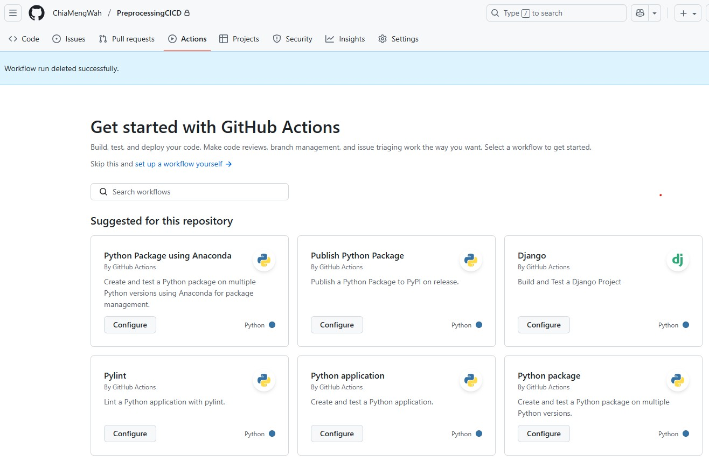

- Copy and paste the contents in the preprocess_stages.yml online and commit the changes.

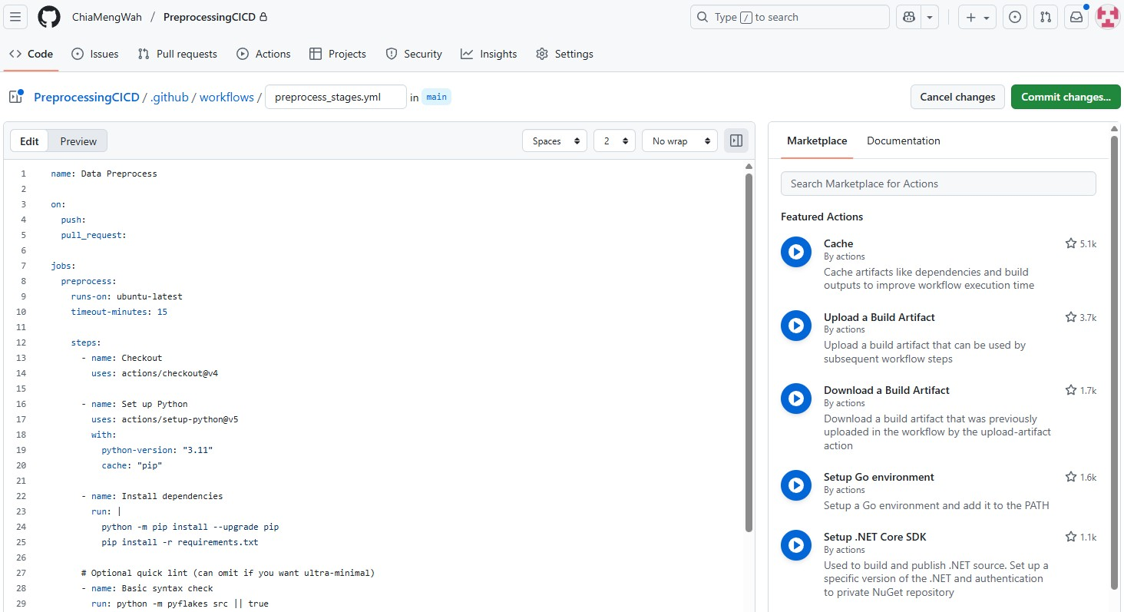

- Once you Commit the changes, the workflow will run. Do ensure that you can successfully set up the workflow (without errors).
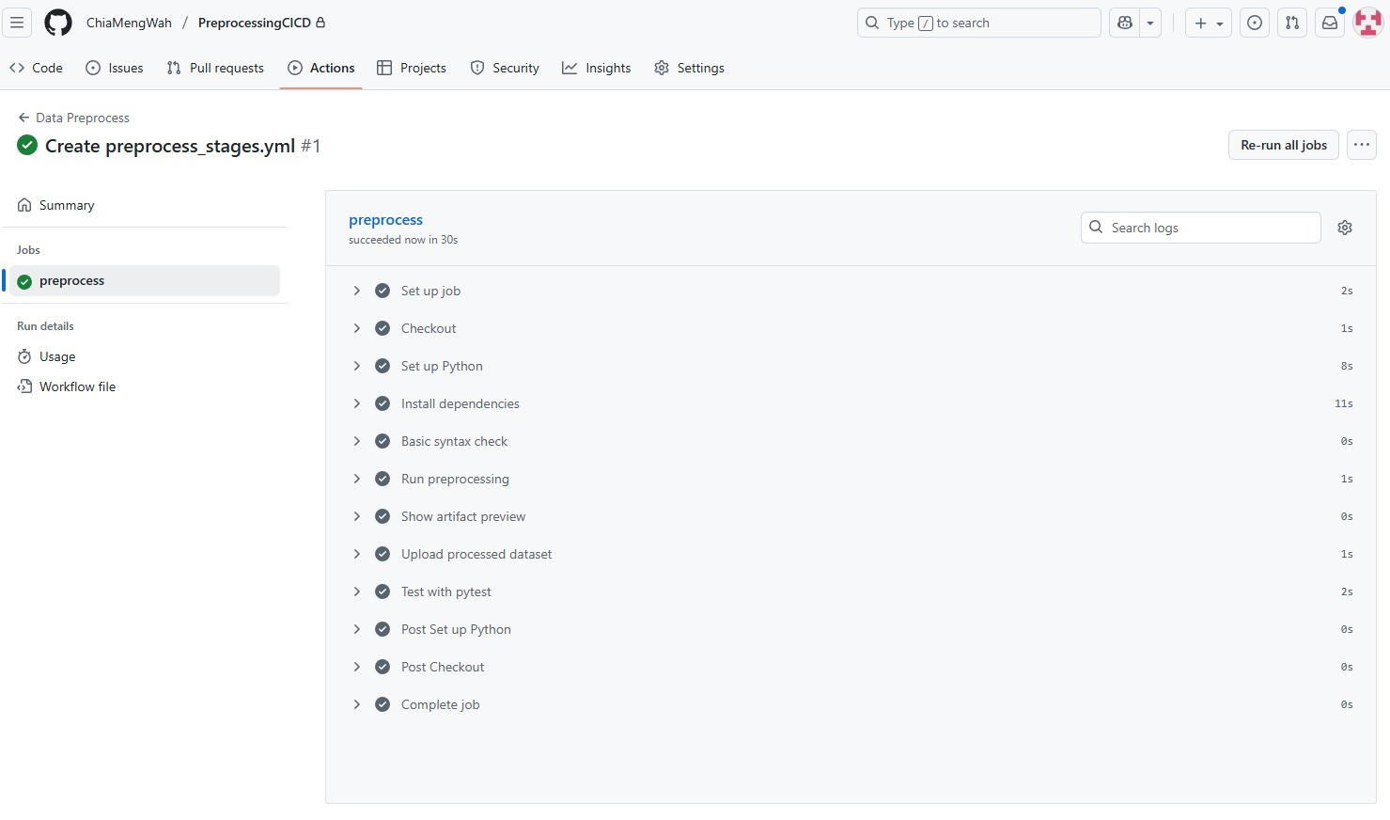

3.3. Testing your CI/CD Workflow with Git push
a) Commit some changes to your repository and observe what happens to your workflow.

Submission for the Week
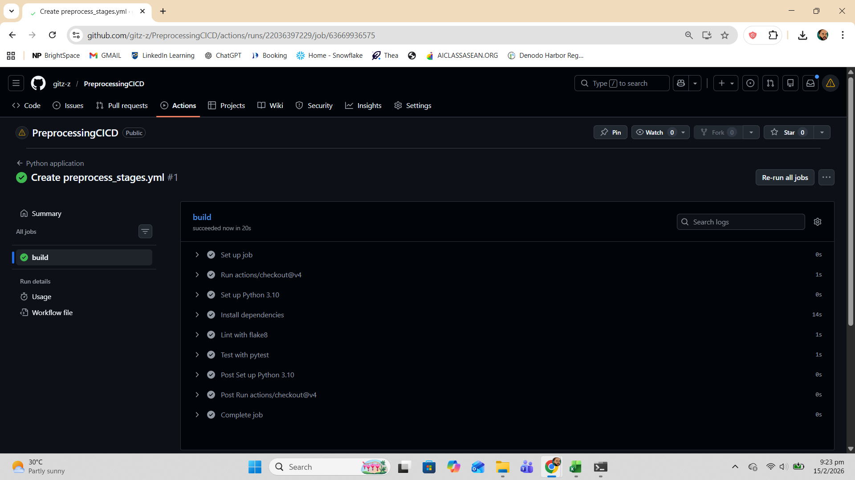
- Provide a snapshot of your repository below with your name and the Actions, i.e. (take note of those fields in the Red boxes)

- Answer the following question:
Reflect on the steps provided in Section 3 and answer the following questions below.
  - What are we trying to achieve in this experiment?
  - How do the processes fit into the machine learning MLops workflow?

Reflection on Section 3: CI/CD Pipeline Implementation
1. Objective of the Experiment
The primary objective of this experiment is to implement a Continuous Integration (CI) pipeline for a machine learning preprocessing project using GitHub Actions. The purpose is to automate validation, testing, and execution of preprocessing scripts whenever changes are pushed to the repository.
Through this exercise, we aim to ensure that the preprocessing pipeline is reliable, reproducible, and systematically validated. Instead of manually executing scripts and tests, the workflow automates dependency installation, script execution, and unit testing. This reduces human error and ensures that any modification to the source code is immediately verified.
Another important objective is to integrate version control with automated quality assurance. By structuring the project into organized directories (such as src, tests, configs, and data), we establish a clear separation of responsibilities. The inclusion of unit tests ensures that preprocessing logic behaves as expected, preventing faulty data transformations from propagating further into the machine learning lifecycle.
Overall, the experiment demonstrates how DevOps principles can be applied to machine learning workflows to enhance reliability, maintainability, and scalability.

2. Integration into the Machine Learning MLOps Workflow
The processes implemented in this experiment correspond directly to key components of the MLOps lifecycle.
Firstly, version control management represents the foundation of MLOps. By maintaining the preprocessing code in a Git repository, we enable traceability, collaboration, and controlled updates. Each commit documents changes and ensures accountability within the development process.
Secondly, the configuration of GitHub Actions establishes Continuous Integration. Every time code is pushed to the repository, the workflow automatically installs dependencies, executes preprocessing scripts, and runs unit tests. This ensures that only validated and functioning code remains in the main branch. In an MLOps context, this protects downstream processes such as feature engineering, model training, and evaluation.
Preprocessing plays a critical role in machine learning systems because data quality directly impacts model performance. If preprocessing logic fails or produces inconsistent results, the entire modelling pipeline becomes unreliable. By automating validation at this stage, the experiment enforces data integrity and pipeline stability before any model development occurs.
Furthermore, automated testing supports reproducibility. The same environment setup and execution process are recreated each time the workflow runs. This aligns with one of the core principles of MLOps: ensuring that machine learning systems are consistent, transparent, and production-ready.
In conclusion, this experiment represents the Continuous Integration layer of the MLOps framework. It transforms a simple preprocessing script into a structured, automated, and quality-controlled pipeline. By combining version control, automated testing, and workflow orchestration, the project demonstrates how machine learning development can be elevated to industry-standard engineering practices.

